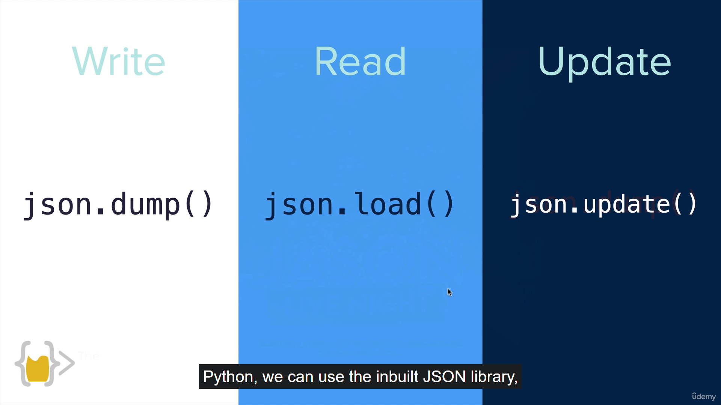

<https://docs.python.org/3/library/json.html>